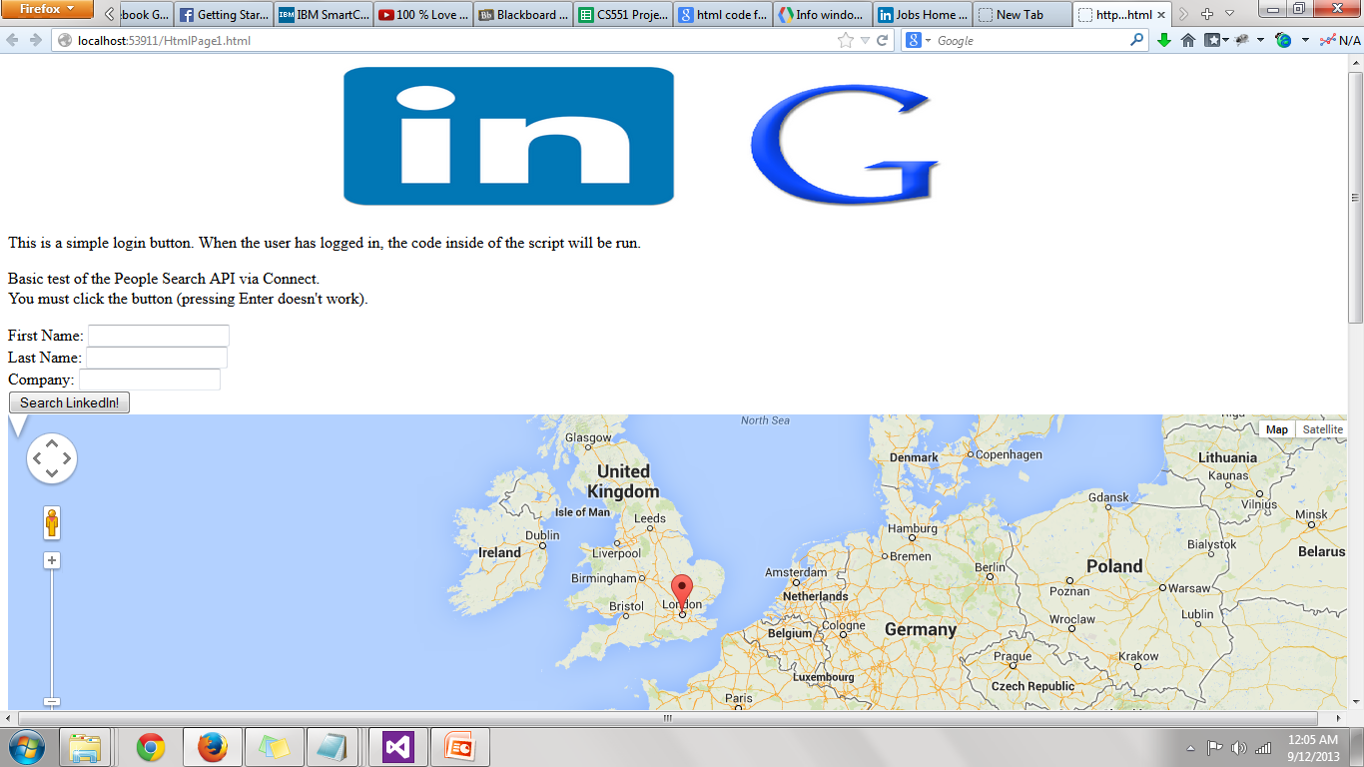My Mash up Application deals with the linkage of the linkedin data with that of google maps, I got the data from the linkedin in a simulation but linkedin does not allow its data due to high security aspects. It’s a big mashup application to find the people of your connections in a google map. However I tried to get the best out of linkedin data but the persons and companies data we obtain from linkedin are their ids which is cumbersome in plotting the markers in the google maps.